Erasmus+ 2016-2018  Young Enterprising Europeans  Osnovna škola Bartola Kašića, Vinkovci | 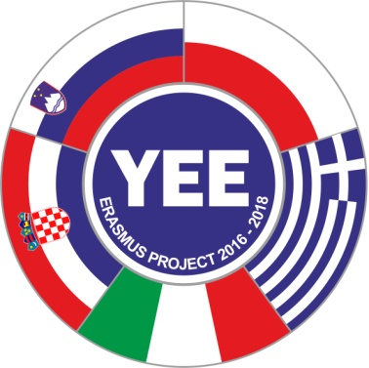
BUSINESS BOARD GAME, Communication
Language: business English
Aim: to develop fluency in a business context
Age: 13-15 years
Teacher: Gordana Maršić
Activity: students answer questions about their job in order to move along the
board and reach the end
Organization: Group work
Time: 20- 25 minutes
Preparation: Making copies of board game (boards with different questions)
for groups of three or four students
Materials needed: board games, figurines, dice, hour glass/stopwatch
Rules: - students are divided into groups
- each player has a figurine (chess piece or something else) , each
group has a dice and a stopwatch
- each student chooses a profession
- students place figurines on START and throw the dice to decide who
starts first
- students throw the dice and move forward that number of squares
- students must answer question on the square. If they succeed talking
for at least 20/25/30 seconds, they remain where they are. If not, they
return to the previous square
- Students take turns, move around the board. The winner is the student
who reaches FINISH first.
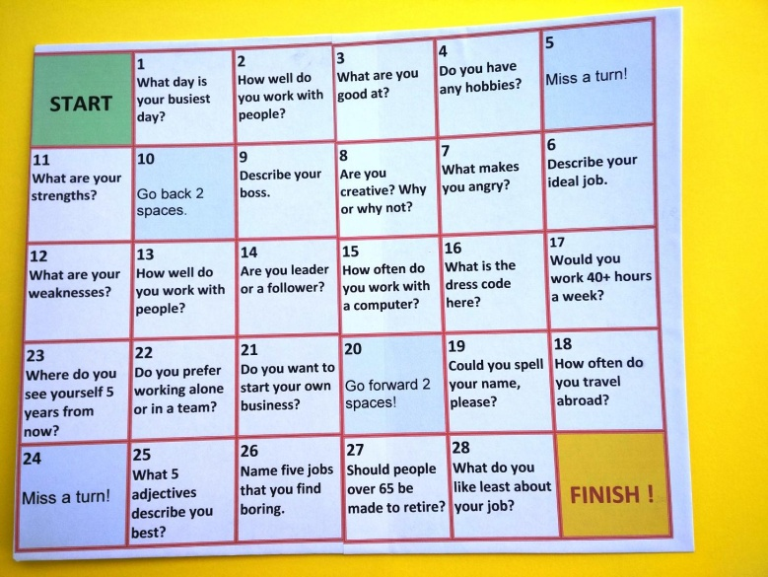 | 