Business board game, Croatia
Erasmus+ 2016-2018
Young Enterprising Europeans
Osnovna škola Bartola Kašića, Vinkovci
BUSINESS BOARD GAME- Smart shopping
Language: business English
Aim: use money wisely, take risks, make smart decisions
Age: 7-14 years
Organization: 4 players, they play against each other
Time: 45 minutes
Materials needed: board games, 4 figurines, 1 dice, cards with products, money
Rules: Pupil plays independently. There are four shops on the bord. In each shop there are five products that can be bought. Under each product there is a price for that product. Each player must buy four products . He/She must buy at least one product in each shop. The winner is the first one to buy four products from four different shops.
Each player gets 1x1 euro, 2x50 cents, 2x20 cents and 2x 10 cents.
The rest is kept in a bank.
Player starts from the bank (red circle in the middle). Players throw the dice, the player with the biggest number starts first in the clockwise direction. Players can move on the outer or inner path. Players must follow the instructions written on the bord. The inner path leads to the bank. Every time a player comes to the bank, he(she gets 20 cents, but it is up to him/her to remember to take the money. If there is no more money left in the bank, the player doesn't get the money. Players need to visit each shop and buy at least one product from each shop. To enter the shop, they must reach an arrow that leads inside. Once inside, player buys a product by taking a card with the product and paying the stated amount. Paid amount is put in the bank.
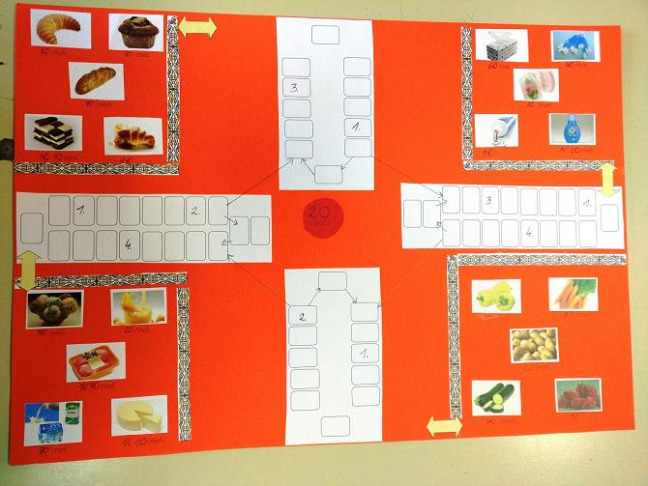 | 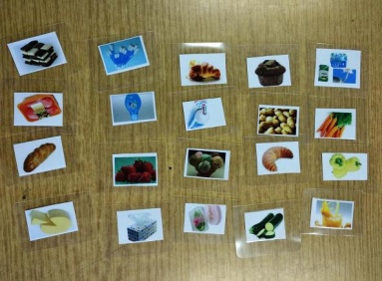
 | 